TRAFFIC MANAGEMENT SYSTEM_PHASE2
INTRODUCTION
Over the years, the focus of traffic management agencies has seemingly been limited to traffic policing. Primarily, this centres on the enforcement of national and state traffic regulations. Priority also looks in the direction of imposing penalties on violators of traffic rules and regulations. The contemporary challenges in the country are however reflecting the failure of enforcement strategies at managing traffic problems. It can be observed that despite the increased number of traffic management agencies, road traffic casualties are increasing. Likewise increase in journey time occasioned by incessant traffic congestion and delays is also a phenomenon. In trying to provide explanations, it is realised that other strategies to road traffic management are either not exploited or not employed at all by the traffic management agencies. In the face of predominant reliance on road transport mode in the country, coupled with the inadequacy of road infrastructure, and poor road users culture, traffic management agencies need to re-tool their strategies. They need three basic traffic management strategies: education, engineering and enforcement to tackle the problem from the root. This book is devoted to explaining those three basic strategies. This is with a view to providing practitioners with fundamental knowledge of traffic management strategies and expose them to the best practices across the world.
PRINCIPLE
The main principles of traffic control in civil engineering include efficient roadway design, proper signage and pavement marking, effective traffic signal timing, clear communication and education for drivers, and continuous monitoring and evaluation of traffic flow.
DESIGN PRINCIPLE
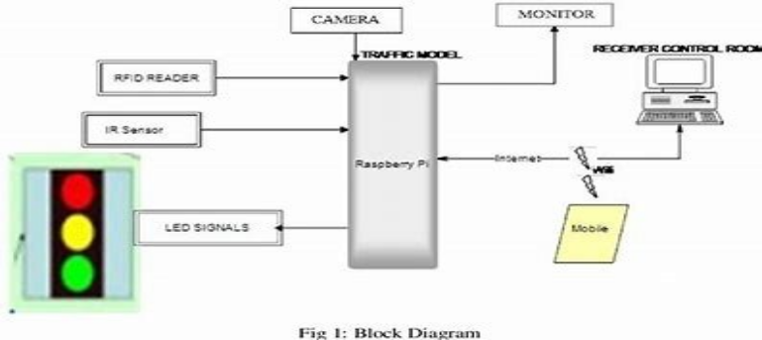
COMPONENTS
1.Camera:
Cameras integrated into smart traffic systems provide real time traffic insights and optimizes the traffic flow. Smart Traffic management has varied applications like ALPR, Traffic Enforcement, Vehicle Detection, Lane Occupancy, Traffic Violation Detection and Traffic Monitoring.
2.Monitor:
Traffic monitoring, also known as network monitoring, is the method of studying the incoming and outgoing traffic on a computer network via specialized hardware and/or software.
3.RFID readers:
The RFID readers are implemented on top of the traffic lights for the interrogation of vehicles that stop in the signals. The RFID tags along with the sensors are placed on the vehicles for the vehicle identification and inspection.
4.LED signals:
- VMS board consists of LED traffic signal system using graphics in monochrome or color to warn and guide the people while driving. Variable Message Sign are widely applicable as highway and traffic control equipments by using programmable LED lights.
- Through the integration of smart terminal technology and mobile communication, MCS technology provides a new way for the transportation system to reduce traffic congestion and vehicle traffic data collection costs [ 11 ]. Which is based on several mobile devices they including smartphones, sensor-equipped vehicles.
5.Receiver control room:
- By definition, a control room is a central location where technicians and managers manage the everyday operations—as well as maintain and enact crisis operations—for a given entity. Whether its a control room for a police station, refinery, or other process-intensive company or organization, the control room is where the magic happens.
- Control. In this article, we are exploring the differences between several types of control rooms.
- 6.IR sensor:
- IR sensor is an electronic device, that emits the light in order to sense some object of the surroundings. An IR sensor can measure the heat of an object as well as detects the motion.
- Usually, in the infrared spectrum, all the objects radiate some form of thermal radiation. These types of radiations are invisible to our eyes, but infrared sensor c...
- Detect vehicle movement and control traffic signals
- Non-contact temperature measurement
- Gas composition analysis and detection
- Non-destructive testing
- IR imaging and night vision
- Optical power meters and sorting devices
WORKING PRINCIPLE
1.Data Collection:
IoT devices, such as cameras and sensors, are installed at various points in the city.
2.Data Transmission:
The data collected by these IoT devices is then transferred to a control room via wireless sensors1. This allows for real-time monitoring of traffic conditions.
3.Data Analysis:
The data is analyzed to optimize traffic flow and keep drivers safe.
4.Communication with Connected Cars:
This aims to reduce accidents around traffic lights and reduce their violation too through better real-time monitoring.
5.Real-time Updates:
The system can transmit accurate information about available parking spaces to citizens in real-time1. It can also alert drivers in case of over-speeding.
6.Maintenance Monitoring: IoT has proved its potential in vehicle maintenance, navigation, monitoring leading to improved transportation2. Vehicle performance and maintenance monitoring help in evaluating the quality of the vehicle and need for maintenance of the vehicle2.
By leveraging these capabilities, an IoT-enabled intelligent traffic management system can help regulate heavy traffic, road blockages at signals & congested networks, thereby improving the comfort and safety of drivers, passengers & pedestrians1.

CONCLUSION
There are a couple more things to mention in regards to implementing ML techniques for traffic prediction.You have to remember that ML/DL algorithms work best when there is sufficient data to train the models and fine-tune them to achieve maximum accuracy. So, the bigger datasets you manage to obtain the better results you will get.Another important point is related to the COVID19 pandemic. Starting early 2020, traffic patterns around the world have changed significantly. For that reason, it makes sense to prioritize the most recent historical data and traffic patterns when building a predictive model.As of today, all the analytics solutions we described above only offer predictions for the near future. And its understandable: Short-term forecasts are obviously more accurate than long-term ones as theres always a chance of unforeseeable circumstances on the road. So, while the possibility to obtain more extended results is still being researched, youll have to find that golden mean that will suit your needs.

